**Histograms of Features of Patient 1:**

**Accelerometer Features:**

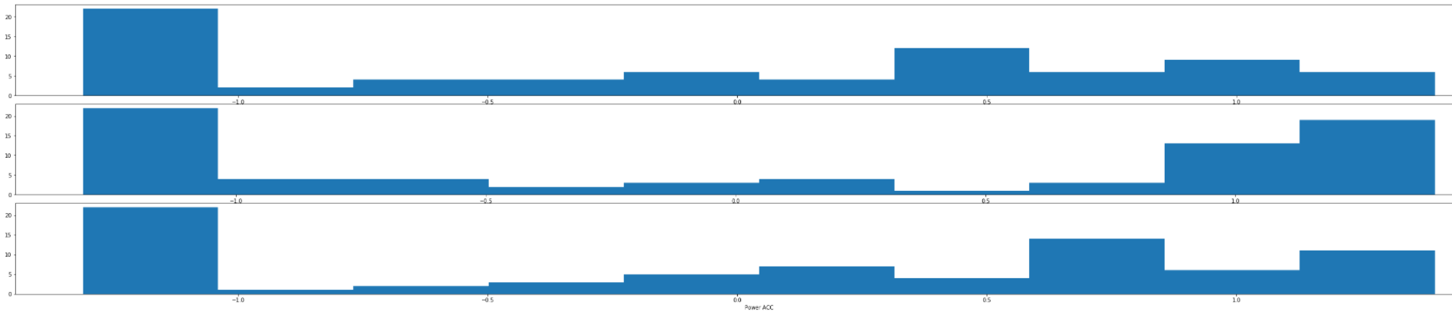

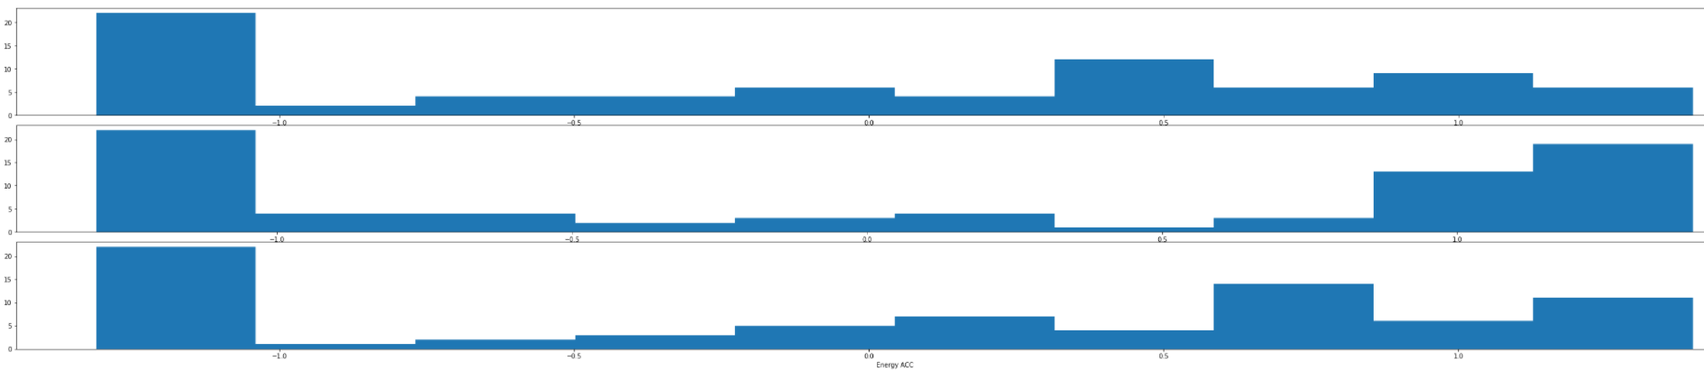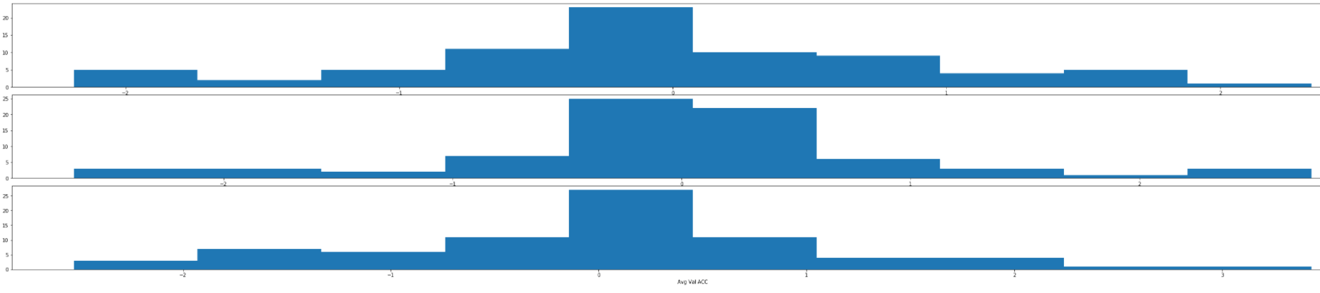

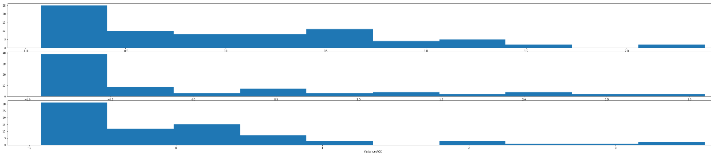

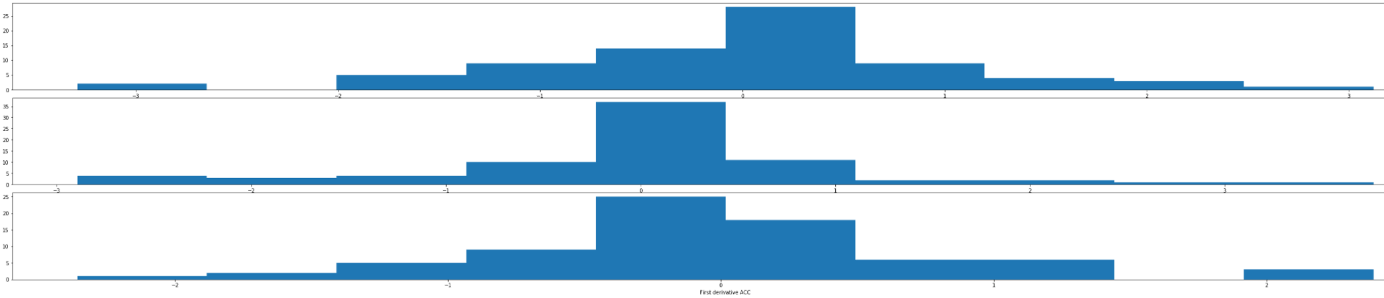

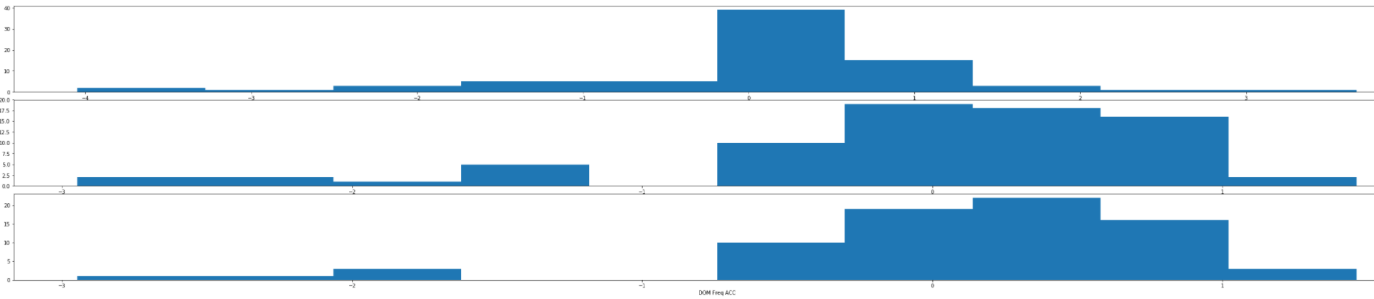

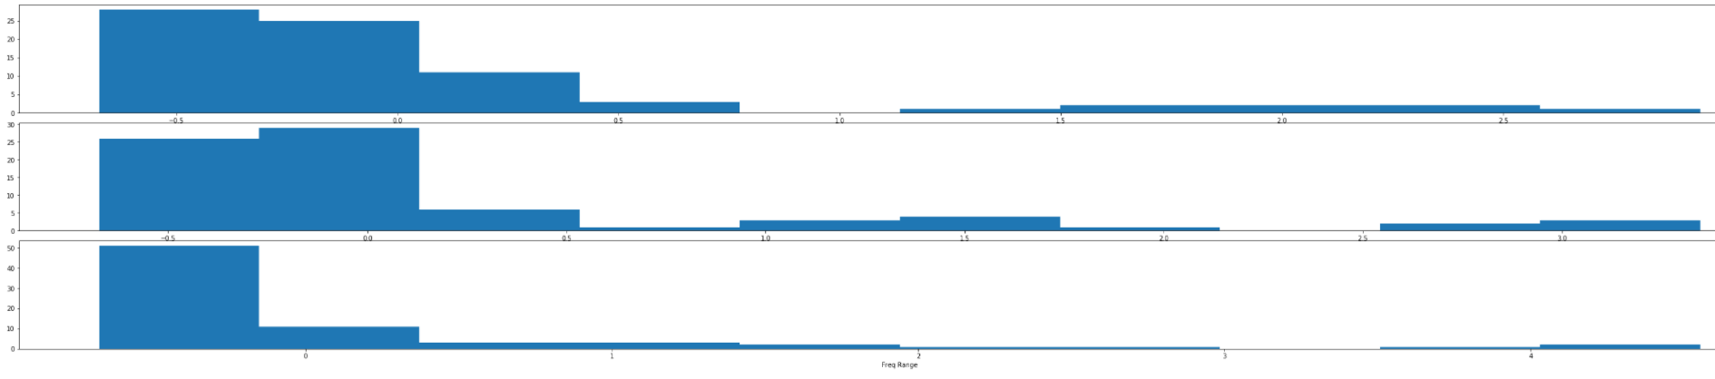

**ACC envelope Features:**

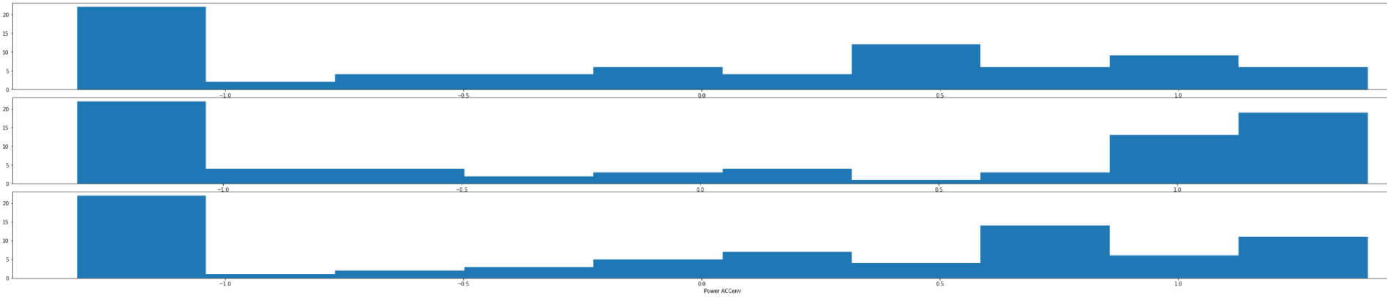

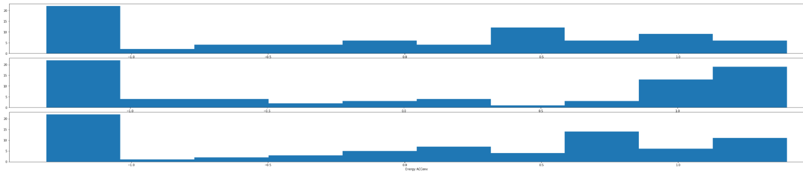

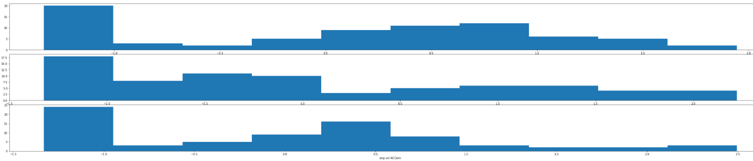

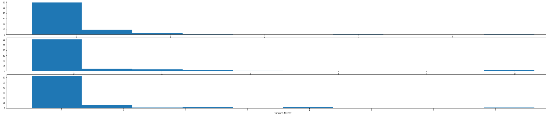

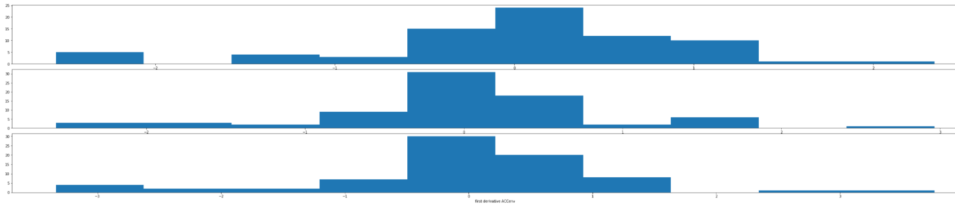

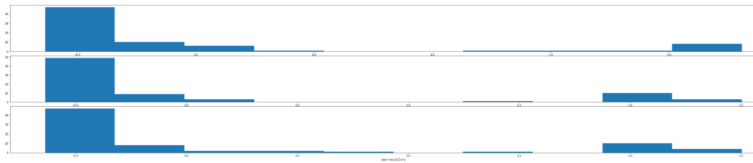

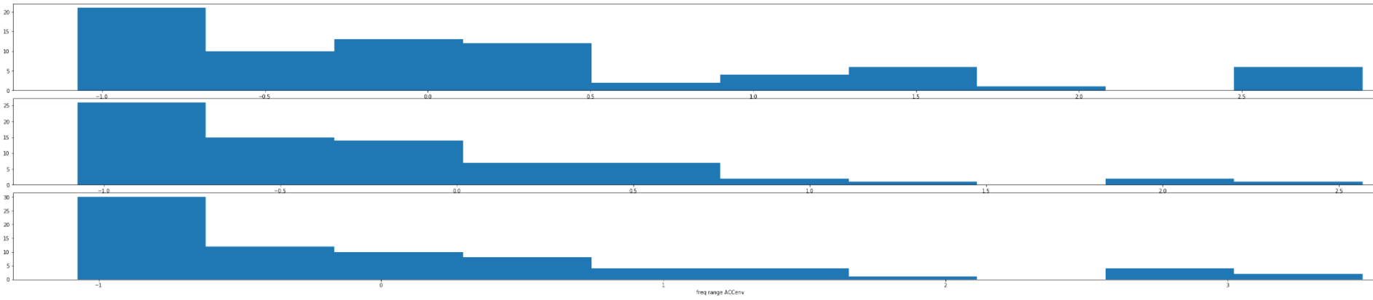

**TSI:**

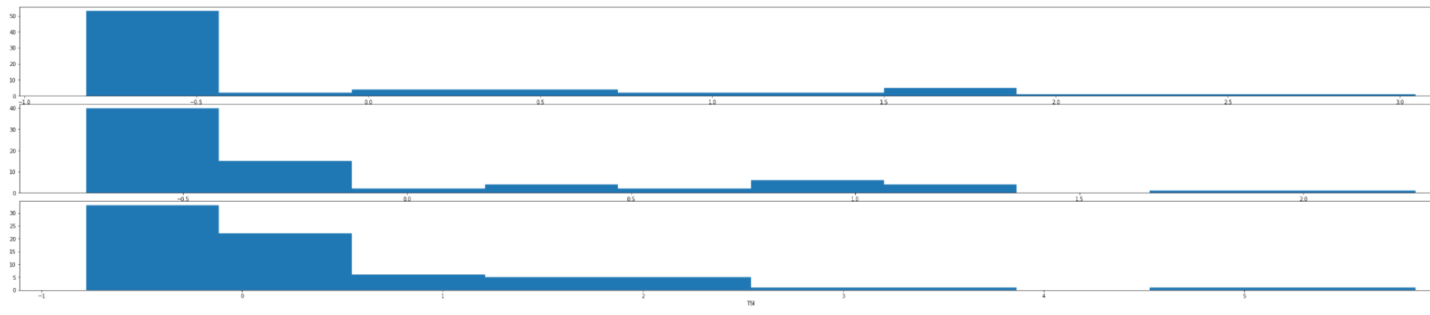

**EMG features:**

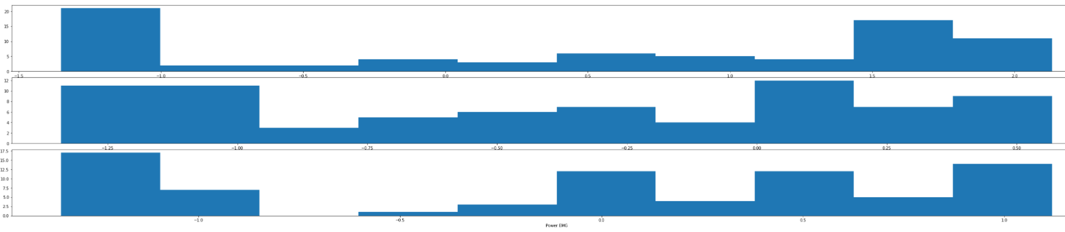

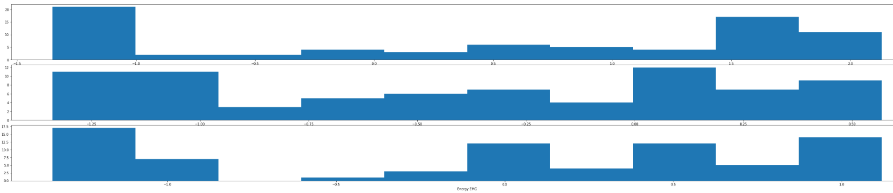

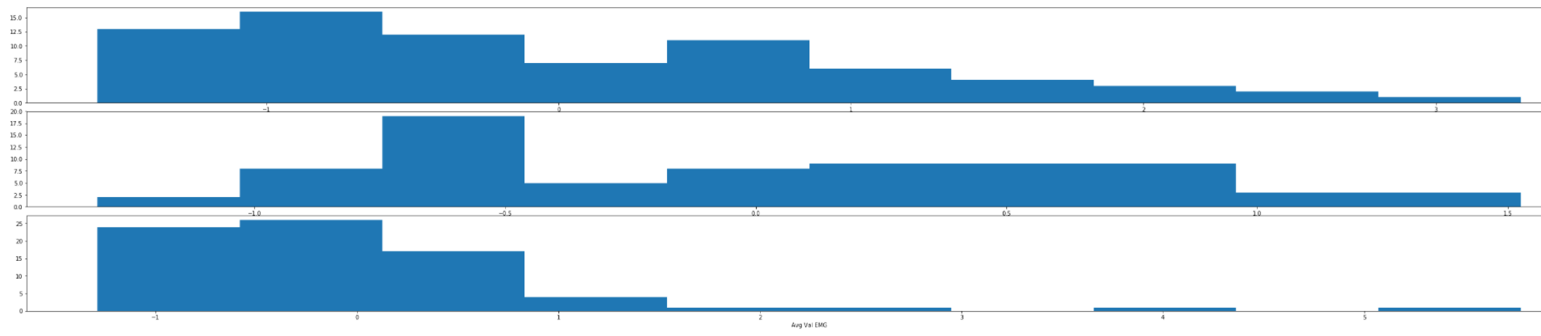

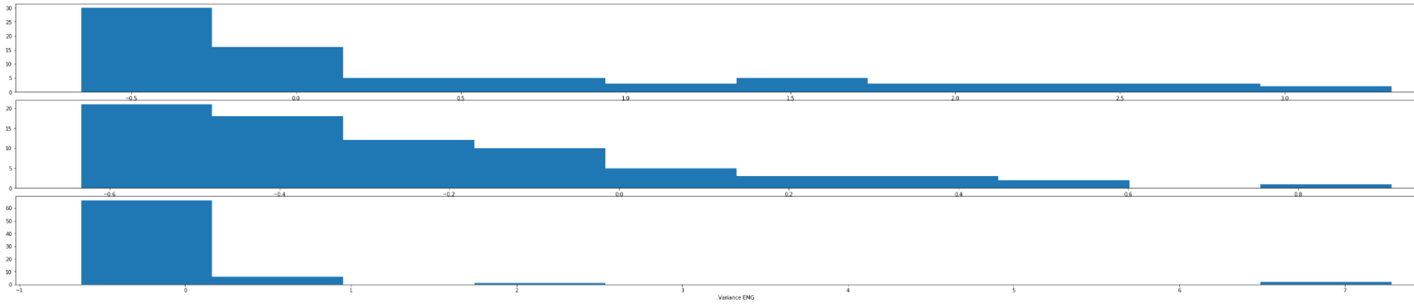

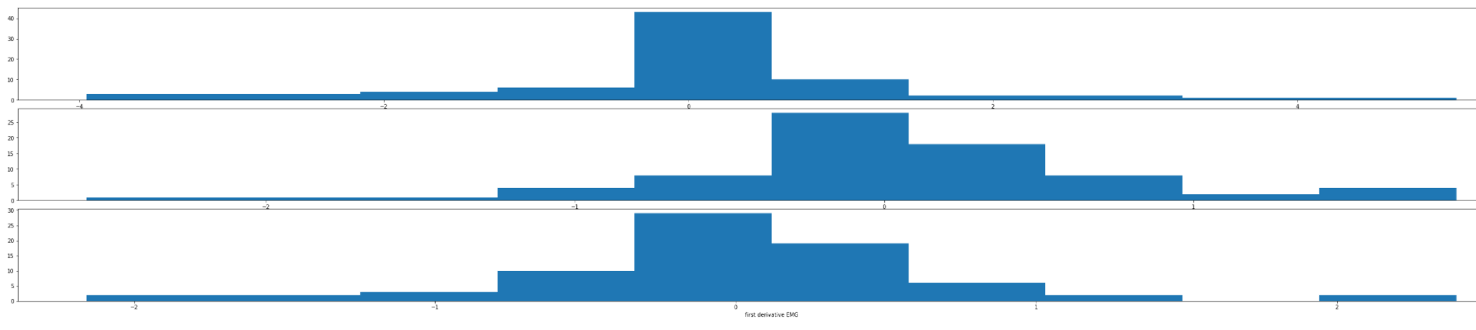

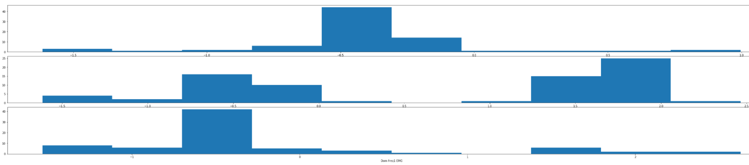

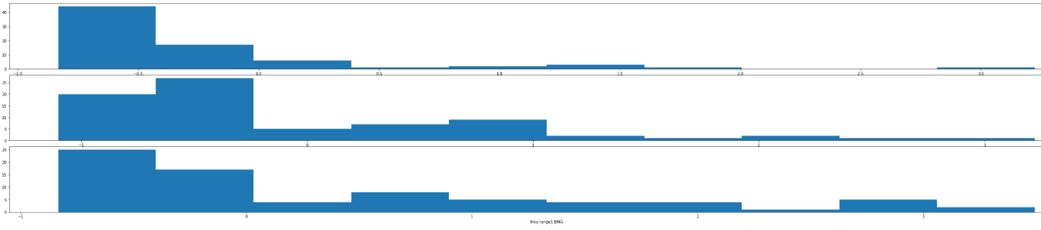

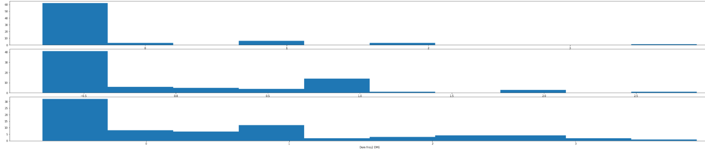

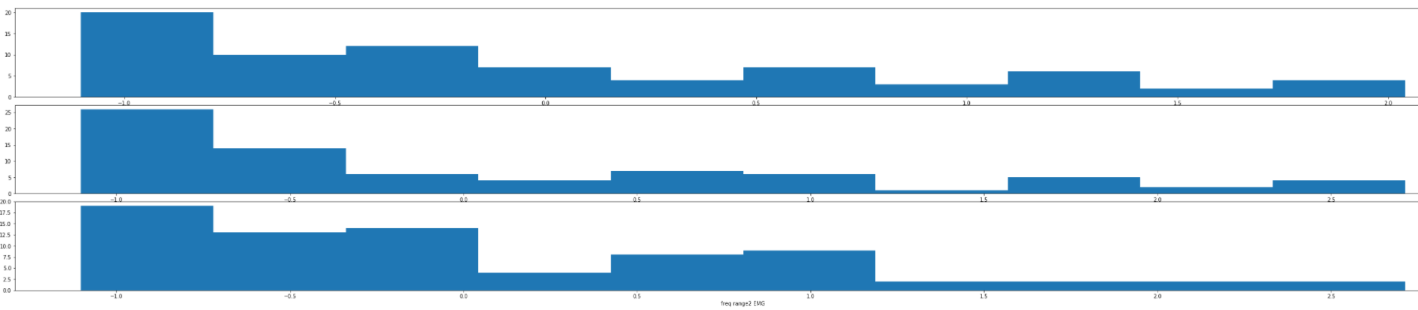

**EMG envelope Features:**

